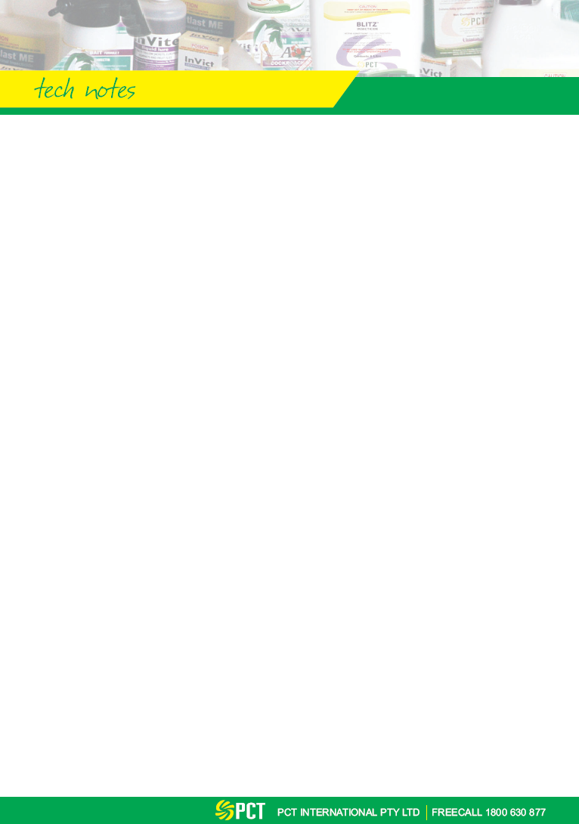

INVADE BIO FOAM

KEY INFORMATION
Pesticide Type: Not Applicable
Pesticide Group: Not Applicable
Active Constituent: Bacillus spp., citrus oil
Concentration: 255 billion cfu per pint
FORMULATION
The product is composed of a premium blend of waste digesting bacillus spores, citrus oil and foaming agent.
PEST CONTROLLED
Larval stages of fruit, drain and phorid flies through breeding site elimination.
SITUATION
Domestic, Commercial, Industrial and Food Handling Establishments.
MICROBIAL BLEND
The microbes used in InVade Bio products are a multiple spore blend designed to provide exceptional performance over a wide range of organic waste-related applications, including drain line and grease trap treatment, hard surface cleaning and deodorizing, septic and waste treatment, and carpet and fabric care. The strains were selected for their superior enzymatic activity against specific substrates including proteins, carbohydrates, and fats and their combined synergistic value as demonstrated in enhanced cell growth, germination rate and effectiveness over a wide range of organic substrates. They will perform in both aerobic and anaerobic environments. Spore-formed microbes are superior in that they are more resistant to chemical cleaning agents. When the spores are in contact with their food source (the target organic matter), they generate bacterial colonies. These bacteria then digest organic matter. While the bacteria can be killed by chemicals, the spores survive and can again produce bacterial colonies when conditions become favourable ( e.g. the chemical is rinsed away).

The spores consist of Bacillus strains (multiple), with no detectable Salmonella or Shigella. Strains are included which produce Lipase, Protease, Amylase, Cellulase and Urease enzymes with aerobic and facultative anaerobic pathways. They are effective at a temperature range of 38 – 145 degrees F. In laboratory tests, the microbe counts double in 20 minutes when in contact with their food sources. They will perform in a pH range of 4.5 to 8.5. They are stable for two years if stored in the range 35 – 95 degrees F.
APPLICATION
Drain Foaming: To push thick foam for several metres down drains, use a power foamer and put a cover over the drain so that the foam gets pushed down through the trap, rather than coming back up and out of the drain. Apply foam when the drain won’t be used for a few hours.

Crack & Crevice Foaming: Fruit flies often are not breeding in drains. Use a hand or power foamer to shoot foam into crack and crevices where scum builds up, such as peeling away baseboards, machinery cracks, beverage line bundles, and beverage fountain drip trays.

MODE OF ACTION
The premium microbes eat through the scum and the citrus oil provides natural degreasing power.
SPECIAL COMMENTS
The premium microbes also quickly knock out the noxious odour-causing bacteria, resulting in excellent odour control fast.

